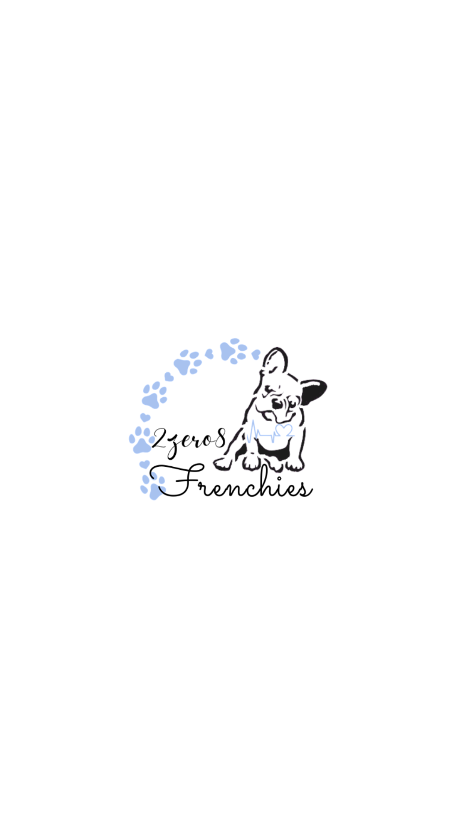

**French Bulldog Puppy Sales Agreement**

This document constitutes an agreement between:

**Seller/Breeder:**

Ryan or Lynette Benzie

208-591-9133

[www.2zero8frenchies.com](http://www.2zero8frenchies.com)

[2zero8frenchies@gmail.com](mailto:2zero8frenchies@gmail.com)

**Buyer/Buyer’s:**

**____ ____________________**

Address:____________________________________

City, State, Zip Code: __________________________

Home #:

Cell #:____________________

Email:____________________

**Pet AKC Registration**: This puppy is being sold with Limited AKC Registration. Spay is required

Non-Refundable Deposit: $_______

Remaining Balance: $_________

* Payments to be made by CashApp or Zelle or Cash (If being picked up in person) or by Financing through Terrace Pet Finance (excluding the deposit) or our In-House Financing options. Both options are on our website. We must have a fully filled out application.
* The Seller reserves the right to void this transaction and refund the Deposit fee for any reason.

**Buyer Initials:___________**

This is a private transaction between the Buyer and the Seller for the purchase of a French Bulldog.

The following are the terms and conditions of this contract.

1. **Purchase Price of the French Bulldog.** (1) The Buyer agrees to the purchase of a French Bulldog Puppy for the amount of (USD) _____ to be paid to the Seller before this contract is effective. The total amount is due by pick up of the puppy (if pick up is in person); or the balance is to be paid, at a minimum, of 5 days prior to ship date.
2. **Identifying information for the French Bulldog Puppy.** (1) The Seller agrees to ship (Buyer will pay for shipping), meet or deliver to the Buyer a French Bulldog puppy with the following characteristics. **Gender:** **_ _______**  **Markings:__ _ _ DOB:___________** (2) The

**BUYER/BUYER’S INITIALS:_______________**

Seller agrees to meet flight nanny at airport on scheduled day for transfer. If Seller neglects or does not meet the flight nanny, for any reason, the Buyer is due a full refund (including deposit).

1. **Registration.** (1) The Seller guarantees this animal to be registered or qualified for registration with the American Kennel Club (AKC). (2)The puppy must contain **2Z8F or 2Zero8 Frenchies in the registered name**. (3) If sold with Limited Registration, the Buyer is to send verification/receipt to Seller, from a licensed veterinarian, that spay/neuter procedure has been performed. If proof is not given to Seller, by designated time, Buyer will be in breach of the contract and a $5,000.00 fee will be paid by Buyer to Seller immediately, or Seller may request for puppy to be returned to them at the Buyer’s expense. If the Buyer is to breed the puppy under a Limited AKC Registration Sales Agreement, the Seller will be in breach of the contract and a $10,000 fee will be paid by the Buyer to the Seller immediately.
2. **Health of the French Bulldog Puppy.** (1) The Seller agrees to deliver, to the buyer, a French Bulldog puppy with no symptoms of infectious or contagious disease. Puppy is warrantied against parvovirus and distemper for 48 hours upon receiving the puppy. The Seller will have a Fecal Test ran the day/or 2 days prior to delivery (Copy of the test will be sent with puppy). The Buyer must have an ELISA test (blood test for Parvo/Distemper) performed within the 48 hours if claiming either of these viruses. Seller must acknowledge receipt of claim, from Veterinarian, for warranty to be valid.
3. **Veterinary Health Certification.** (1) The Seller guarantees that the French Bulldog puppy has been certified as healthy by a licensed veterinarian. (2) The Buyer agrees to pay for a licensed veterinary health examination and obtain a health certificate within three days of taking possession of the puppy. (3) The Buyer agrees to forward the written veterinary health certificate to the Seller to VALIDATE the health guarantee within 24 hours of the exam. The terms and conditions of this contract are not effective until the Seller has acknowledged receiving the certificate. (4) The Buyer agrees to assume any financial responsibility for this examination, veterinary expenses and/or medications are not covered in this contract. (5) After 3 days, the Buyer assumes all responsibilities for the bulldog puppy and there are NO REFUNDS after the initial 3 days for any reason.
4. **Health Warranty.** (1) The warranty period for this puppy is ONE year from **DOB**. This warranty covers fatal and life threatening congenital diseases. The puppy must show defect within the one-year warranty. This includes: (a) Severe hip dysplasia (must be confirmed by x-ray and be graded as severe and requiring euthanasia or surgery, does not cover if was an accident on the Buyer’s fault. Mild/moderate dysplasia is not covered, as it is impossible to determine if it is congenital or environmental. Environmental means through repeated trauma to the undeveloped joints through rough play, too much exercise, jumping on and off of furniture and decks, etc. (b) Life threatening heart defects (heart murmurs must be a grade 3 or higher). (c) Severe spinal abnormalities (Most French bulldogs have at least one or more hemi-vertebrae & DNA test will show they carry these genes.) Replacements for spinal issues will be discussed on a case-by-case basis considering the quality of life of your dog, the opinion of your vet, and whether surgery is necessary. (Please do NOT let your dog jump from high surfaces, as this can increase the chances of a normal hemi-vertebrae & hip displasia becoming problematic.) Hemi-vertebrae found in routine x-rays, that are not problematic will NOT be considered for replacement. (d) Liver shunts (e) Luxating patellas (must be at least a grade 4 to warrant a replacement) (f) Any other LIFE THREATENING CONGENITAL defects will be discussed on a case-by-case basis. Buyer understands that conditions not listed in this contract are not guaranteed for replacement. (2) If the French Bulldog Puppy dies within this contract’s effective period, the Buyer agrees to assume financial responsibility for an autopsy (necropsy) on the puppy, to be performed by a licensed veterinarian to determine the cause of death. (3) Buyer agrees to forward the written autopsy report to the Seller. (4) If the cause of death is found to be any affliction listed in the health warranty section (6.1) Of this contract, the Seller agrees to replace the puppy with one of similar identifying characteristics as those listed in the identifying information for the French Bulldog Puppy section (2.1) of this contract, unless characteristics are unavailable to the Seller or otherwise specified by the Buyer (minus the cost of shipping) (5) Buyer agrees that there is no monetary refund of any kind, full, or partial guaranteed or implied. (6) The puppy must exhibit the fatal and life-threatening congenital defect within

**BUYER/BUYER’S INITIALS:___________**

the effective period of this contract. (7) The Buyer agrees to notify the Seller of the problem, as well as furnish veterinary reports by two unassociated licensed veterinarians stating the affliction within two business days of the problem’s discovery. A speculative or inconclusive diagnosis WILL NOT warrant a replacement puppy from the Seller. If the Buyer decides to not return the puppy, this contract is VOID.

1. **Health Conditions.** (1)This guarantee does not apply to afflictions that are considered to be common in the bulldog breeds. These include, but are not limited to, cherry eye, skin tags, entropion (in-turned eyelids), ectropion (turned out/loose droopy eyelids), “loose” hips and elbows (bowed/fiddle front), luxating patella’s (less than a grade 4), skin tumors including but not limited to mast cell tumors, straight stifles, splayed feet, pinched nerves, any hernias (as these are non-life threatening and can be corrected at time of spay/neuter), skin allergies, elongated soft palate, stenotic nares, collapsed nostrils, hanging tongue, inverted vulva, kinked, crooked, or inverted tails, tail pockets, hot spots, yeast infections, ear infections, under bites, crooked teeth, wry jaw, excessive shedding, difficulties in house/crate training and skin issues like dry-flaky skin (in most cases this can be fixed with a change in diet and adding supplements). (2) Any kind of parasites, bacteria or viruses and sicknesses (such as coccidian, giardia, and kennel cough) which could be associated with the afflictions listed in section 7.1 of this contract or environmental factors, will not be covered by this guarantee. Including allergies (in most cases allergies are related to certain foods and can be alleviated with a change in diet and some are environmental. It is not uncommon to have seasonal grass, weed, and pollen allergies, dysfunction, demodectic mange and other autoimmune disorders. (3) The Seller does not assume responsibility for any reason to any vaccination. (4) The Seller does not assume responsibility for any medical expenses incurred associated with any health problem. Buyer understands he/she will be responsible for all vet bills incurred after taking possession of the puppy. (5) This guarantee does not apply to any physical problems, which could be the result of an injury. (6) This guarantee does not apply to the presence of deafness or any kind of hearing problems.
2. **Puppy Care.** (1) The Buyer agrees to provide the puppy with routine preventative care, with a Licensed Veterinarian, and follow a veterinarian guideline for vaccination and deworming. (2) The Buyer agrees to **keep the puppy away from dog parks, grassy areas, pet stores, etc until the puppy is at least 16 weeks of age and has received final vaccination (includes not letting puppy walk on the floor at the vets office).** (3) The Buyer agrees to keep the puppy away from lakes, rivers, oceans and other bodies of water where the puppy can be in danger of drowning, unless proper safety protocol is followed. (4) The Buyer agrees to provide adequate fresh water, quality food and rest to the puppy. (5) The Buyer assumes responsibility for protecting the puppy from loss, theft, danger, neglect, and abuse. (6) The Buyer agrees to house the puppy **indoors** and only take outside for exercise and to relieve itself. The Buyer agrees to house the puppy **indoors** and only take outside for exercise and to relieve itself. (7) The Buyer is aware the French Bulldog’s do not handle heat well and agrees to take appropriate action to keep the puppy safe from heat stroke.
3. **Return Policy.** (1) A puppy eligible for replacement, pursuant to section 6 of this contract, must be returned or euthanized with prior permission from the Seller to qualify for replacement. (2) The returned puppy must appear in good condition to the Seller, other than the specified problem. (3) A puppy will NOT be eligible for replacement if it has been or appears to have been neglected, abused, bred, or euthanized without prior written permission from the Seller. (4) The Buyer agrees to assume financial responsibility for all transportation costs incurred for transporting the returned puppy to the Seller.
4. **Owner Agreement.** (1) The Buyer agrees that **UNDER NO CIRCUMSTANCES**, and at any time, will this puppy be sold, leased, or given, to anyone or to any pet shop, shelter, or research facility. Therefore, the Buyer agrees that if at any time they can no longer care for the puppy/dog that the Seller **MUST** be notified and given the right of first refusal. Seller will assist in the placement of this dog or Seller may elect to take the dog back themselves with no payment made to the Buyer. Buyer certifies that this purchase is not made by the Buyer as an agent for any other person or entity, and further agrees that neither dog or its offspring (if sold with breeding rights), shall be sold to any agent, pet shop, mass commercial kennel, puppy mill, farm breeding facility, or research breeding facility. (2) Buyer is aware that whoever signs this contract is the one given the sole possession of said dog. In the event that there is a divorce, break up, move, etc., the dog is to remain with the party that has signed the contract below. If you cannot keep the

**BUYER/BUYER’S INITIALS:____________**

dog then it is to be returned to the Seller unless otherwise agreed upon with the Seller in writing. (3) If at any time you have a “change of mind” you will NOT be issued a refund. The dog is to be returned to the Seller, at the Buyer’s expense, and a credit voucher may be given to the Buyer for the purchase of a puppy at a later time that is more suitable for you. (The voucher is offered on a comparable dog of size, color, and structure as the original one the Buyer had chosen.) (4) If you are unable to care for your puppy, the Seller is to be notified immediately for return of the puppy to the Seller, at the Buyer’s expense. (5) If at any time the puppy is to pass away, for or of any means, the Seller is to be notified within 72 hours.

1. **Responsibility.** (1) It is understood that the Seller assumes no responsibility, after puppy leaves the premises, for any change of mind on the Buyer’s part such as; property owner’s disapproval, allergies, disagreement of family, trouble with housebreaking, etc. (2) Register AKC & Microchip promptly in order to facilitate it’s return if lost or stolen. (3) When asked twice a year, current pictures must be provided within 48 hours or a reasonable time frame mutually agreed upon in case of vacations. This can be done via Facebook or email. By neglecting to send updates, Seller will assume that the dog has been sold, traded, given away, hurt, thrown outside in a kennel/shed/chained, deceased, etc. Seller will then be forced to act as if the dog is being neglected and reinforce our contract through the legal system. (4) We do highly recommend looking into and or having a good Pet Insurance.
2. **Dispute.** (1) This is the entire purchase contract; no other promise or stipulations are included or implied in this sale. (2) In any and all legal action pertaining to this dog, this contract shall be considered to be legally binding. (3) In the event of any dispute or disagreement under this contract, the laws of Idaho will

govern the resolution of the dispute and venue for resolution of any dispute will be in Elmore County Idaho. (4) To the extent that any provision of this contract may be invalid under any law of the state of the buyer, all remaining provisions remain binding. (5) It is further understood that the buyer will be responsible for all the seller’s attorney and court fees. Ie: Including but not limited to: filing fees, attorney fees, missed wages and traveling fees.

1. **Final Agreement**. (1) This purchase agreement has been read and understood by both parties. In the event that the Buyer should breech or attempt to falsify claims against this contract there will be a $1000.00 fee assessed to them as well as any other fees associated with each point in this contract, depending on what was breached.

**By signing this agreement, we affirm that we have read, understand, and agree to abide to the terms and conditions.**

BUYER/BUYER’S SIGNATURE(S):__________________________DATE:_______________________________

SELLER(S) SIGNATURE(S):_______________________________________DATE:_________________________________